Jiawei Wang
Problem 1：
At the beginning of the generation of telephone network, the wires was chaos. The first phase of computer network is establishing the multiple circuit controllers.
Then, in 1969, the Packet Switch Network arise, means entering the second phase of computer network.
1977, the proposal of OSI model indicates that the computer network moves into third phase.
Now broadband networking has been come into our life.
Problem 2:
VOIP (voice over internet phone)
VOIP means that digitize analog signals. Transmit the data packet in the IP network in time. Encoding the voice data and then packet the data according to the standard of TCP/IP, then send the packet to the destination. Decoding the packet, recover it into voice signal. In our real life, for example, facetime or using Facebook to make a voice call both are using VOIP technology.
Problem 3:
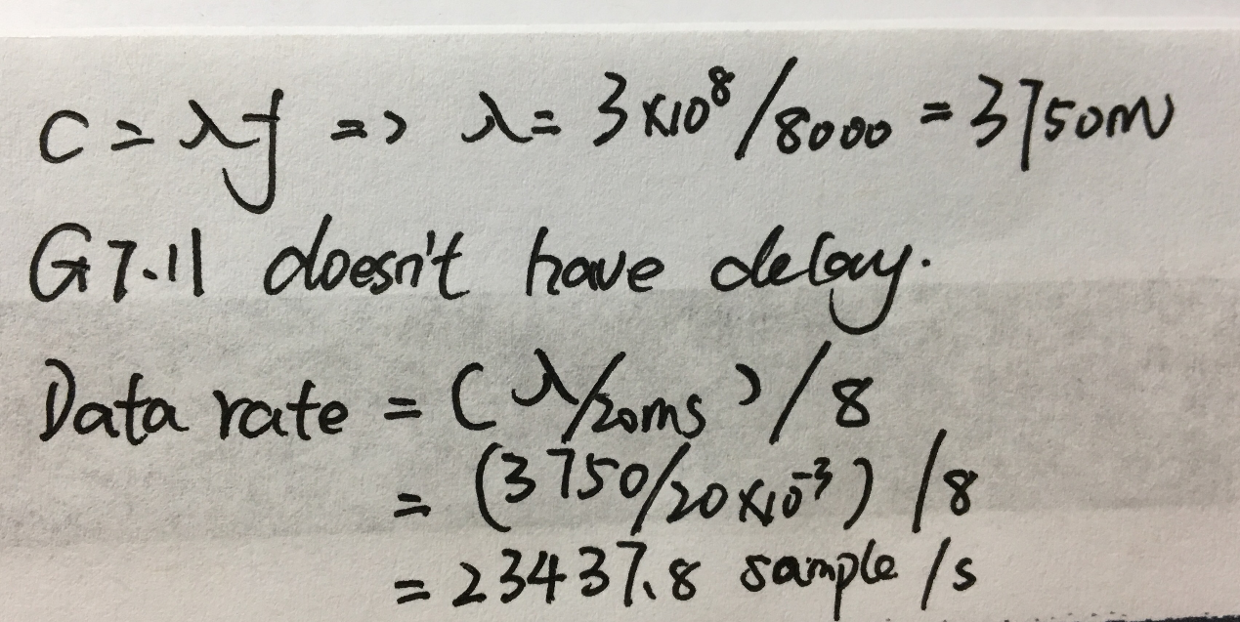
Problem 4:
Multiplexing is the transmission of multiple data communication sessions over a point-to-point physical link.
(a) TDM(Time Division Multiplexing);
Two or more signal can be transmit in a common spectrum.
(b) FDM(Frequency Division Multiplexing)
One channel can only transmit one signal is a waste. So TDM means that divides the spectrum into several band, each user can use exclusive band.
Such as FM Radio.
(c) CDM(Code Division multiplexing)
Based on the different encoding to distinguish the original signal. The advantages of CDM is the utilization of spectrum resource is high.
Problem 5:
(a)DNS: Domain name system
Translating between addresses and convert between hostname and IP.
(b)ARP: Address Resolution Protocol.
Contains request and reply.
Request:
- Find Mac address.
- APR sends broadcast asking for MAC address.
- Destination host replay with it MAC address.
- Cached in ARP table.
Reply: unicast
- Need to go through a router
- Routing table provides address of router
- APR will find MAC address of the router if not find cached APR table.
(c)DHCP: Dynamic Host Configuration Protocol.
Automatic configuration of remote host.
(d)ICMP: Internet Control Message Protocol.
ICMP is a network layer protocol, it first encapsulated into IP datagram before go to next lower layer.
Problem 6:
I would like to introduce DHCP (Dynamic Host Configuration Protocol). There are 4 steps.
- The client makes a request for an IP address.
- The DHCP servers offer an IP address.
- The client selects an offer and requests an IP lease.
- The selected DHCP server assigns an IP to client.

Problem 7:
(a)
MAC (Media Access Control) address: a unique identifier assigned to network interfaces for communications at the data-link layer of a network segment.
IP address: An Internet Protocol address is a numerical label assigned to each device connected to a computer network that uses the Internet Protocolfor communication.
(b)
Problem 8:
(a) Symbol means data symbol.
In digital communications, symbol rate means baud rate, it the number of symbol changes across the transmission medium per time unit using a digitally modulated signal or a line code.
(b) Bit rate means that in the unit time, processing data, the unit is bps (bit per second). Bit rate is higher, the transmit rate is high.
Baud rate is modulation rate. 1 baud is the rate of the symbol.

Problem 9:

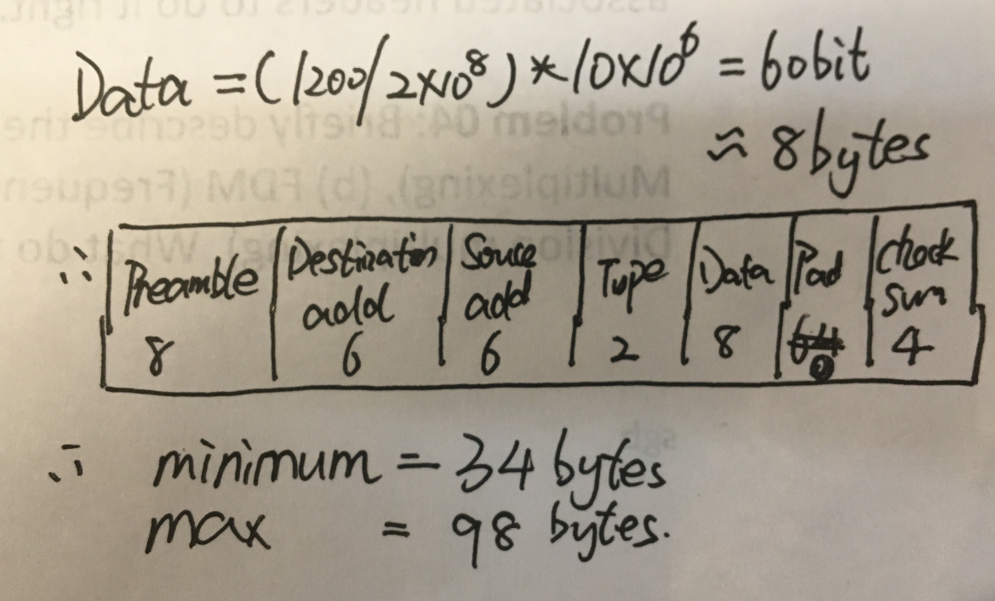

Problem 10:
